The Promise for PCOS game-changers: myo-inositol supplementation

May 16, 2025



# Greetings

**Dr. Amr Gaafar**

Obstetrics and Gynecology consultant

Alexandria university

* Founder and director of Continental center for women’s healthcare (Smouha, Alexandria and Sheikh Zayed, Cairo, Egypt).
* Co-Founder and treasurer of Middle Eastern Society for Adolescent and Pediatric Gynecology (MESPAG).
* PCOS is a public health concern and optimal management is not achieved.
* Nature gifted us with great solutions to our problems.
* A better future for PCOS cases is here.
* The future is myo-inositol.

## myo-inositol: Not experimental any more

* Inositol is a sugar made in the body and found in foods
* myo-inositol and D-chiro-inositol are the most common forms found in supplements.
* myo-inositol is naturally present in both animal and plant cells (as a free form or in phospholipids)
* Backbone for numerous secondary messaging signaling
* Essential for proper glucose metabolism.
* Directly involved in cell growth and in reproduction physiology.
* During a physiological menstrual cycle, signals from the hypothalamus–pituitary– gonadal (HPG) axis promote the progression of folliculogenesis through the stimuli of FSH and LH.
* Inositol cascade is primarily involved in the signaling of insulin and gonadotropins.
* In 2018 ESHRE guidelines, it was considered experimental in PCOS management.(1)
* In 2023 ESHRE guidelines, myo-inositol became an evidence-based recommendation.(2)

ESHRE 2018



ESHRE 2023

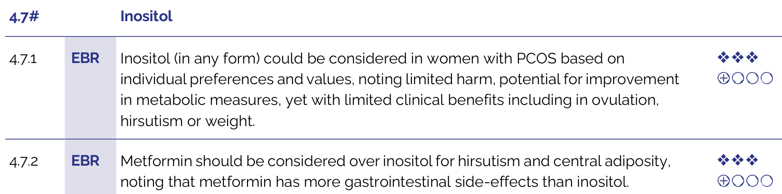

* All living cells contain myo-inositol phospholipids in their membranes
* Human diet from either animal and plant sources contain myo-inositol.
* Now let’s **play and guess** which is a good source of myo-inositol

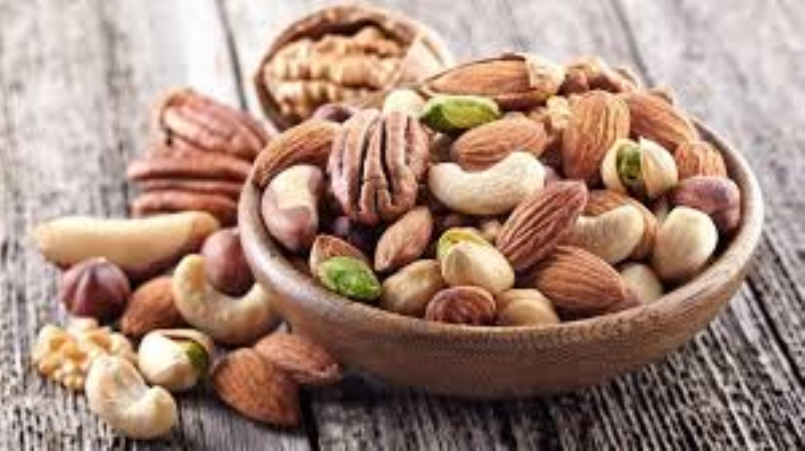

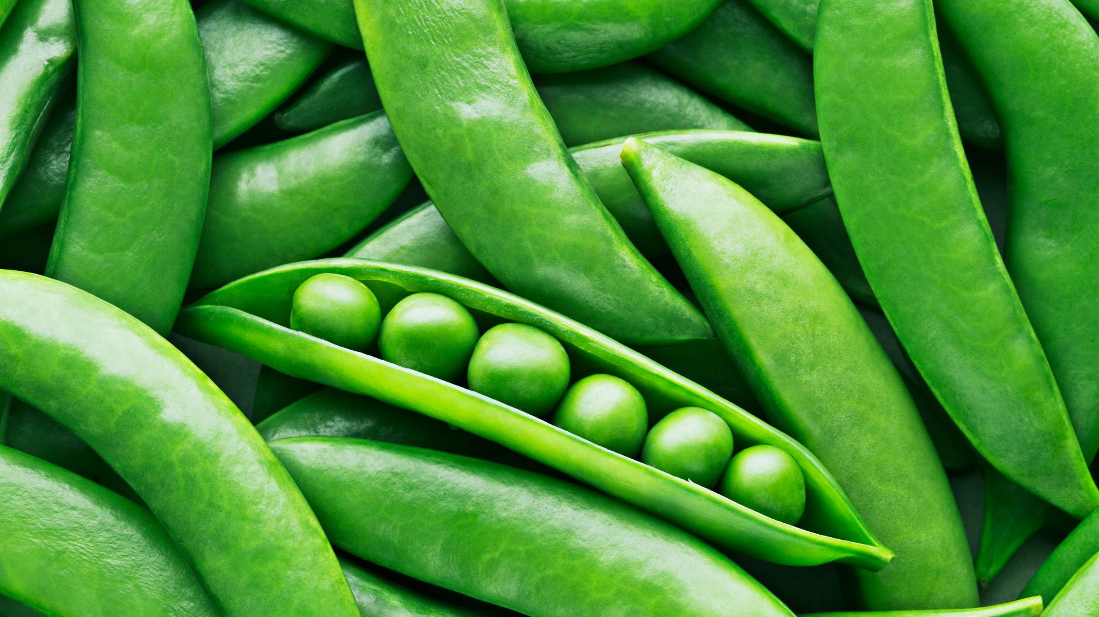

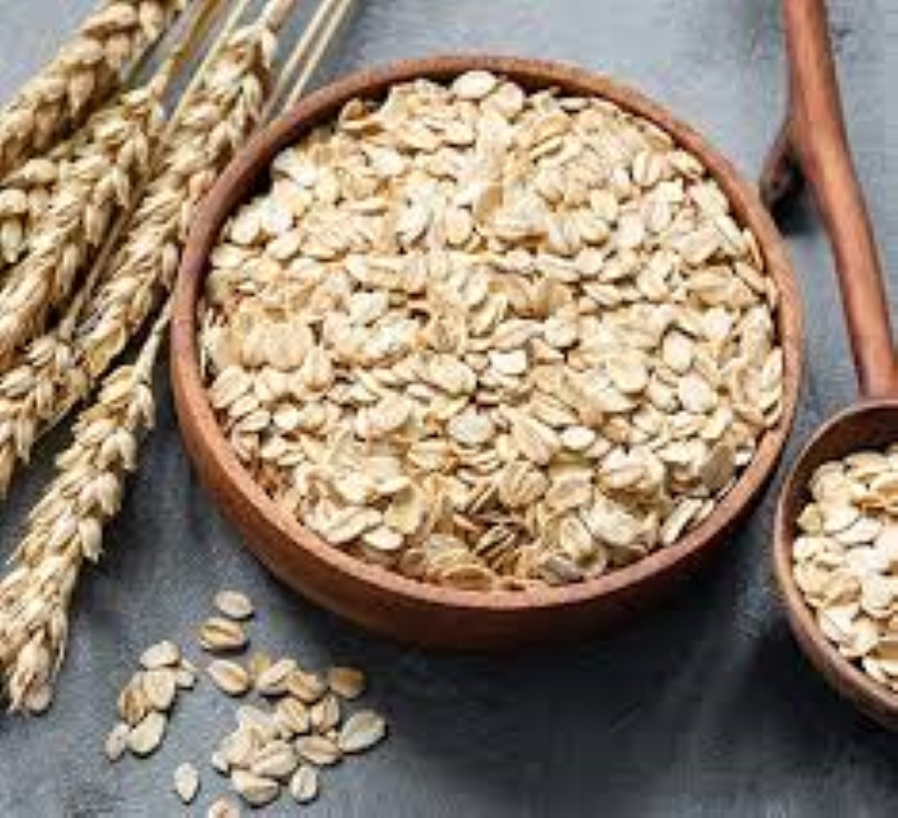

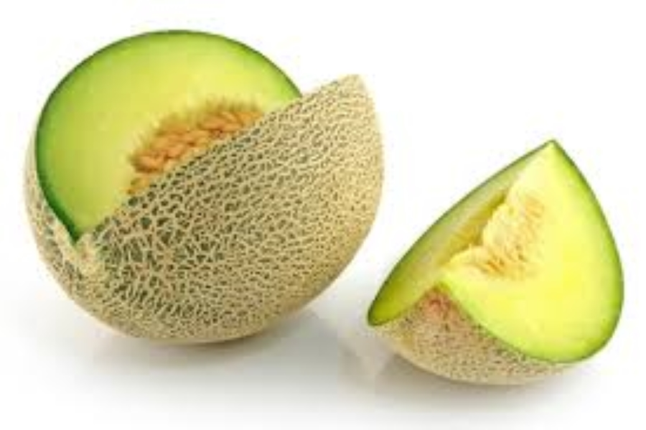

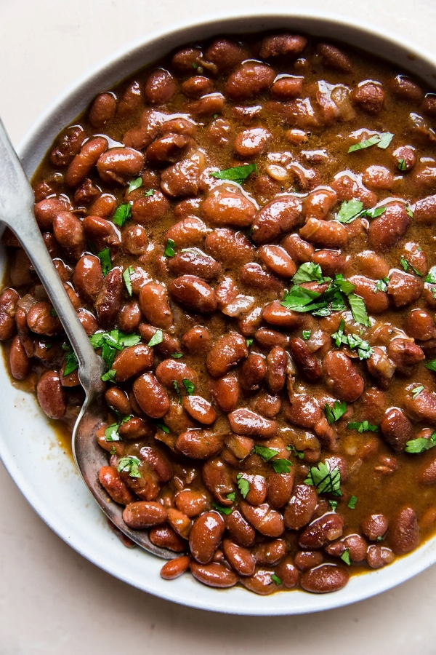



* Look for seeds and fresh fruits/vegetables
* Leafy vegetables are poor in myo-inositol



# Get to Know myo-inositol

* Was once considered to belong to the vitamin B family
* Even if you don’t know its values, your body can’t ignore it.
  + **de novo synthesis** from D-glucose
* Good **absorption and availability**
  + Nearly 99.8% of ingested amount is absorbed.
  + Normally, the circulating fasting plasma myo-inositol concentration = **30 µM**.

# myo-inositol and Diabetes

* Disturbed Inositol metabolism is associated with **insulin-resistance**.
  + myo-inositol supplementation → insulin-mimetic effects in DM and PCOS models.
* Low concentration predicts long-term DM **microvascular complications**.
  + In DM complicated kidney, sciatic nerve, retina and lens, depletion of intracellular myo-inositol is documented human subjects.(3)

# Magical Spell for PCOS

Associated with improvement in:

1. Hyperinsulinemia.
2. Metabolic parameters.
3. Hyperandrogenism.
4. Ovarian function.
5. Ovulation induction.
6. Oocyte quality.
7. Embryo quality

* myo-inositol supplementation seems to be a simple, safe and effective first-line treatment for women with PCOS.(3)
* Main **mechanism of action**:(3)
  + Improving **insulin sensitivity** of target tissues,
  + Refreshing the reproductive axis, and
  + Better hormonal functions (reduction of clinical and biochemical hyperandrogenism and of dislipidemia).

# More PCOS magic with myo-inositol

* Improved insulin peripheral **sensitivity** and insulinemia.(3)
* Leaner **anthropometric** measurments (after 16 weeks or more of treatment).(3)
* **Hormonal parameters:**(3)
  + ↓ LH, FSH,and testosterone circulating levels, and
  + ↑ SHBG, estrogens and progesterone circulating levels
  + Restore spontaneous ovarian activity
  + ↑ Fertility
* **Cardiovascular parameters:**(3)
  + ↓ systolic and diastolic blood pressure,
  + ↓ plasma triglycerides,
  + ↑ HDL cholesterol,
  + ↓ LDL and total cholesterol concentrations.
* A meta analysis revealed that effects of myo-inositol supplementation trespassed achieving conception.(4)
* Interestingly, myo-inositol proved to be a significant supporter of physiological gestation as well fertility
* myo-inositol supplementation was associated with successful ovulation and restoration of regular cycles.
* Additionally, significantly lower odds of GDM was seen in patients who received myo-inositol.
* Encouraging data from clinical trails of myo-inositol have been consistently published
  + Reviews of published studies available since 2012.
* A 2014 **review** provided level Ia evidence of significant improvements in hormonal and reproductive aspects of PCOS cases.(5)
* **Not only abundance, but balance**
  + In PCOS cases, an imbalance between Inositol isomers (mainly myo- and chiro-inositol) leads to a reduction in insulin and FSH signaling.(6)
  + A myo- to chiro-inositol ratio of **40:1** is thought to be physiological for most tissues

# Superior ART outcomes with myo-inositol

* Pre-treatment of myo-inositol is a very new method that was evaluated in multiple small studies to manage poor ovarian response in assisted reproduction.
* Increasing evidence indicates that inositols play a vital role, namely in **oocyte and spermatozoa development**.(6)
* Via both petentiated **signaling** and appropriate **glucose** for growth maturation.(7)
  + In the ovary, myo-inositol mediates the granulosa response to FSH stimuli.(7)
* It also plays a crucial role in determining oocyte maturation.(7)
  + Adequate myo-inositol (in PCOS cases) = proper glucose available for growing oocytes.(6)

## Supplementation with myo-inositol during ART

* In both PCOS and non-PCOS women, with myo-inositol supplementation during ART:
  + Lower amount of **gonadotropins** required
  + Better **oocyte quality and maturation**
  + Healthier **embryo development**, and
  + Significantly higher rate of **successful pregnancies**.

# But what about Metformin?

* Recent studies further empower myo-inositol as a competitive insulin sensitizer.
* Direct comparative studies vs. Metformin were conducted

# myo-inositol vs. Metformin in PCOS

* A **RCT** reported that while improvements in anthropometric measurements were noted with both myo-inositol and metformin, the magnitude of improvement was **comparable** between the two treatments.(8)
* A 2023 **meta-analysis** concluded that both are **equally beneficial** in improving metabolic and hormonal parameters.(9)
* **In ART:** A 2022 study reported that myo-inositol was associated with significantly **better outcomes** in PCOS women receiving **antagonist cycles**.(10)
* **myo-inositol** was reportedly **safer** than Metformin.
* Adverse events were 5 times more common with Metformin compared to myo-inositol.(11)
  + With Metformin: abdominal pain, lactic acidosis, and generalized weakness.
  + With myo-inositol: nausea, mild diarrhea, and menorrhagia.

Haven’t she heard about myo-inositol?



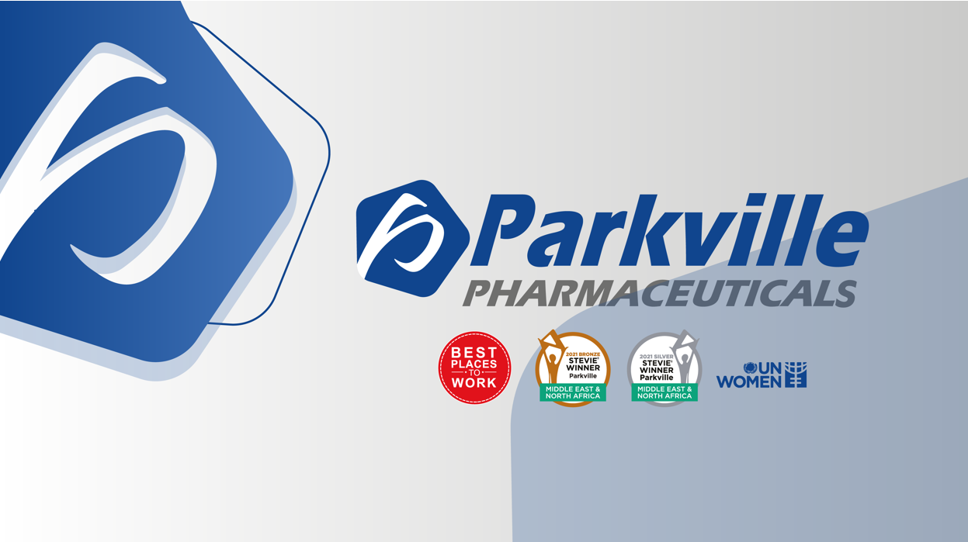

# Coenzyme Q10

* Coenzyme Q10 (CoQ), is an endogenous lipophilic quinone.
* CoQ10 supplementation was linked to:
  + Greater response to **ovulation induction**.
  + Decreased odds of fetal **aneuploidy**.
  + Lower cycle **cancellation rate**.
  + Higher odds of a **clinical pregnancy**.

Even in women older than 35 years, CoQ10 is associated with:(12)

* Larger **quantity** and better **quality** of oocytes.
* Optimized oxidative metabolism of **follicular fluid**.
* Boosted **mitochondrial function** of oocytes.
* Better odds of a successful pregnancy.



# Methylfolate

* myo-inositol is not the only supplement with growing supporting evidence in PCOS.
* Methylfolate is now believed to be a superior approach to folic acid supplementation.
* Supplementation with methylfolate is as effective as treatment with folic acid.
* However, unlike folic acid, methylfolate is an active compound and doesn’t need enzymatic transformation.
* This is why methylfolate is not affected by functional polymorphisms in Methylenetetrahydrofolate reductase (MTHFR) gene.
* MTHFR gene mutation can cause infertility and/or recurrent pregnancy loss if methylfolate is not supplemented.
* Recently developed drug compounds now include both myo-inositol and methylfolate supplementation with required doses.



# Take Home Message

It’s myo-inositol, sweet and discreet,

Found in beans, fruits, and whole grains you eat.

It whispers to cells, “Let insulin in,”

And helps ovaries get back to their spin.

No medals, no thanks, not even a clap—

Just hiding in food like a watchful champ.

It helps with the sugar, the cycles, the skin—

But no one says, “Hey! That’s what helped me win!”

# On the Shelf



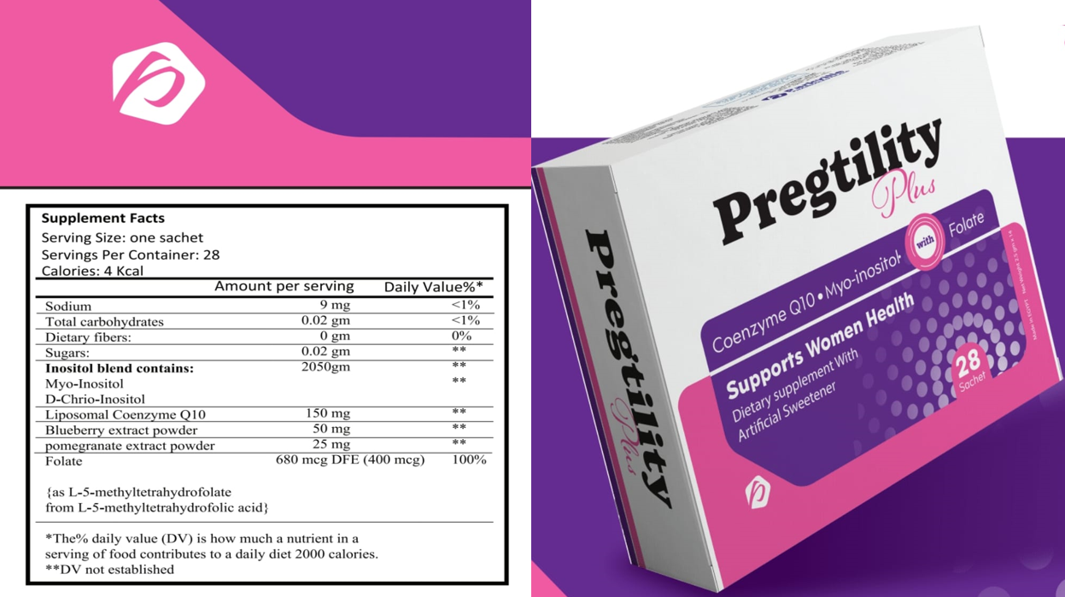

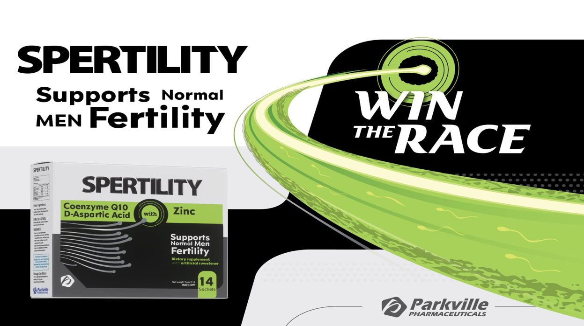

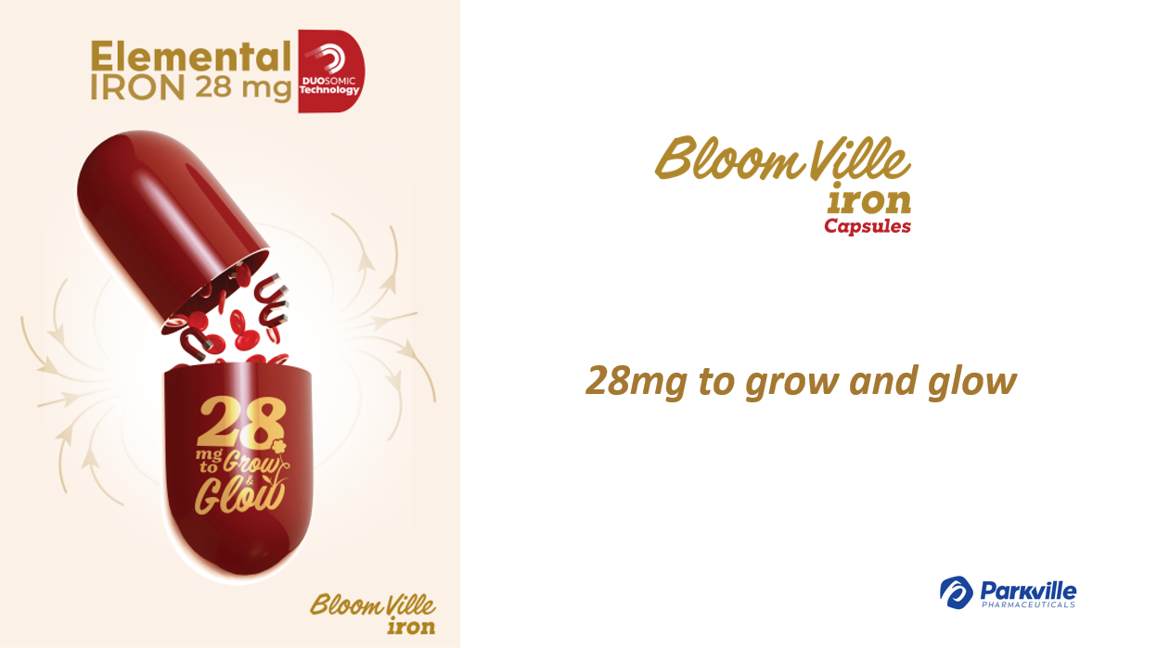

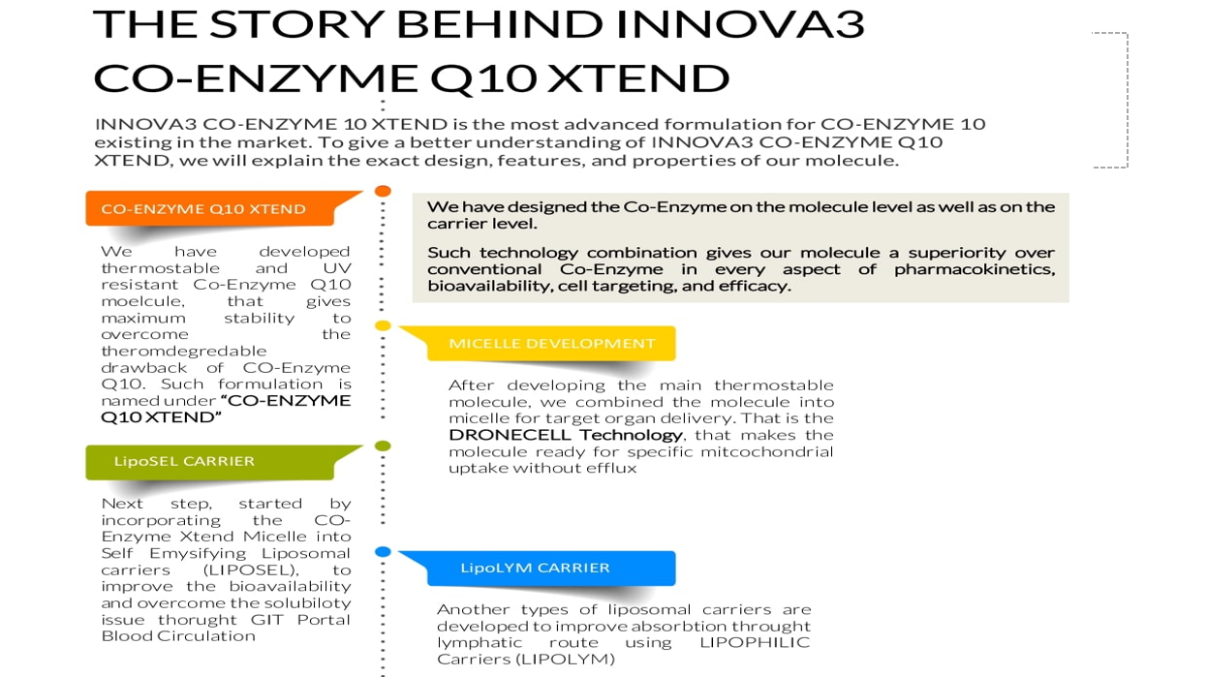



QR code for slides and references

# Refrences

1. Teede HJ, Misso ML, Costello MF, Dokras A, Laven J, Moran L, et al. Recommendations from the international evidence-based guideline for the assessment and management of polycystic ovary syndrome. Human reproduction. 2018;33(9):1602–18.

2. Teede HJ, Tay CT, Laven J, Dokras A, Moran L, Piltonen T, et al. International evidence-based guideline for the assessment and management of polycystic ovary syndrome 2023. 2023;

3. Croze ML, Soulage CO. Potential role and therapeutic interests of myo-inositol in metabolic diseases. Biochimie. 2013;95(10):1811–27.

4. Gambioli R, Forte G, Buzzaccarini G, Unfer V, Laganà AS. Myo-inositol as a key supporter of fertility and physiological gestation. Pharmaceuticals. 2021;14(6):504.

5. Unfer V, Carlomagno G, Dante G, Facchinetti F. Effects of myo-inositol in women with PCOS: A systematic review of randomized controlled trials. Gynecological Endocrinology. 2012;28(7):509–15.

6. Bevilacqua A, Carlomagno G, Gerli S, Montanino Oliva M, Devroey P, Lanzone A, et al. Results from the international consensus conference on myo-inositol and d-chiro-inositol in obstetrics and gynecology–assisted reproduction technology. Gynecological Endocrinology. 2015;31(6):441–6.

7. Etrusco A, Laganà AS, Chiantera V, Buzzaccarini G, Unfer V. Myo-inositol in assisted reproductive technology from bench to bedside. Trends in Endocrinology & Metabolism. 2024;35(1):74–83.

8. Nehra J, Kaushal J, Singhal SR, Ghalaut VS. Comparision of myo-inositol versus metformin on anthropometric parameters in polycystic ovarian syndrome in women. Education. 2017;11(22):8.

9. Fatima K, Jamil Z, Faheem S, Adnan A, Javaid SS, Naeem H, et al. Effects of myo-inositol vs. Metformin on hormonal and metabolic parameters in women with PCOS: A meta-analysis. Irish Journal of Medical Science. 2023;192(6):2801–8.

10. Rajasekaran K, Malhotra N, Mahey R, Khadgawat R, Kalaivani M. Myoinositol versus metformin pretreatment in GnRH-antagonist cycle for women with PCOS undergoing IVF: A double-blinded randomized controlled study. Gynecological Endocrinology. 2022;38(2):140–7.

11. Facchinetti F, Orru B, Grandi G, Unfer V. Short-term effects of metformin and myo-inositol in women with polycystic ovarian syndrome (PCOS): A meta-analysis of randomized clinical trials. Gynecological Endocrinology. 2019;35(3):198–206.

12. Lin G, Li X, Jin Yie SL, Xu L. Clinical evidence of coenzyme Q10 pretreatment for women with diminished ovarian reserve undergoing IVF/ICSI: A systematic review and meta-analysis. Annals of medicine. 2024;56(1):2389469.